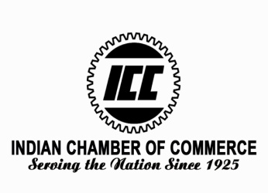
9th edition of National legal Summit
19th January 2019
India Habitat Centre, New Delhi

Delegate Registration Form

Organization: - ...................................................................................................................................................

Address: - ..........................................................................................................................................................

........................................................................................................................................................................

Delegate Details –
S.No | Name | Designation/ Organization | Email | Phone No.

Category | Registration Fees
Non Members | *Rs.3000/- per delegate
ICC Members/ICMAI Members | *Rs.2000/- Per delegate
Students | **Rs.1000/- per student
Overseas Participants | US $ 100

Please find enclosed our Demand Draft/Cheque no …………………dated ……….……… drawn for Rs./USD. .............................in favor of ‘Indian Chamber of Commerce’ towards the participation fee of the above listed participants for 9th edition of National legal Summit 2019.
*GST as applicable **Copy of Student ID Card needed
- Group Discount of 10% on the total participation fee on nominating 2 or more delegates from your organization.
- Pre-Registration is must for participation.
- Delegate Fee is non-refundable & cannot be adjusted to any other ICC event however change in nomination is possible.
- Only one discount category can be availed.

For further details please contact:-
Ms. Yatika Kashyap
Mobile No:-8376815137 / Phone 011 4610 1435
Email id: yatika.kashyap@indianchamber.net
Indian Chamber of Commerce Kailash Building,
26 K G Marg, Flat No. 807, New Delhi – 110001

